[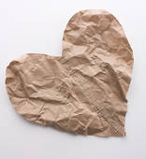](http://www.fotosearch.com/bthumb/CRT/CRT007/78573-43dg.jpg)

-->

Crumpled papers

With poems of you

Writ with words

That won’t ever come true

Ingrained on a fabric

That’ll never fray

The hopeful words

I wish, I could say

Hands still shaking

As I continue to write

Scribbling meagre letters

In black and white

Across this darkness

Blinded, as I wend

With these broken pieces

That I cannot mend

Eager to tell you

How I feel

Just praying I could prove

My love is real